
Rackmount Chassis 2U12SSR

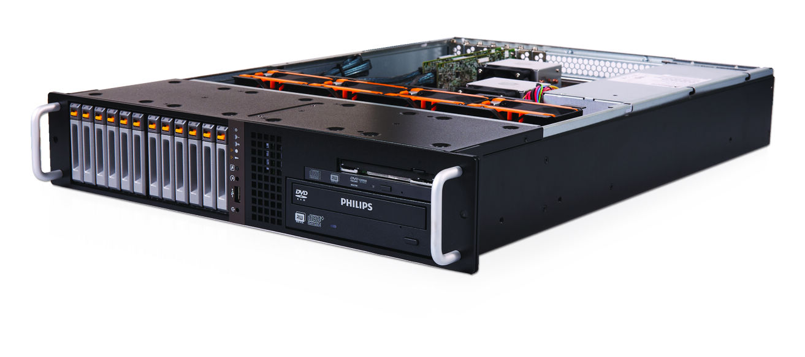 | 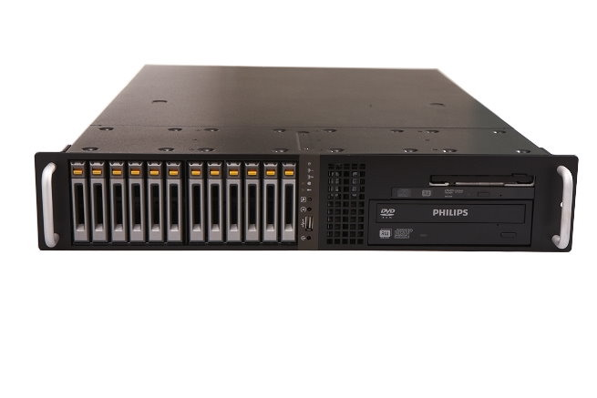
 | 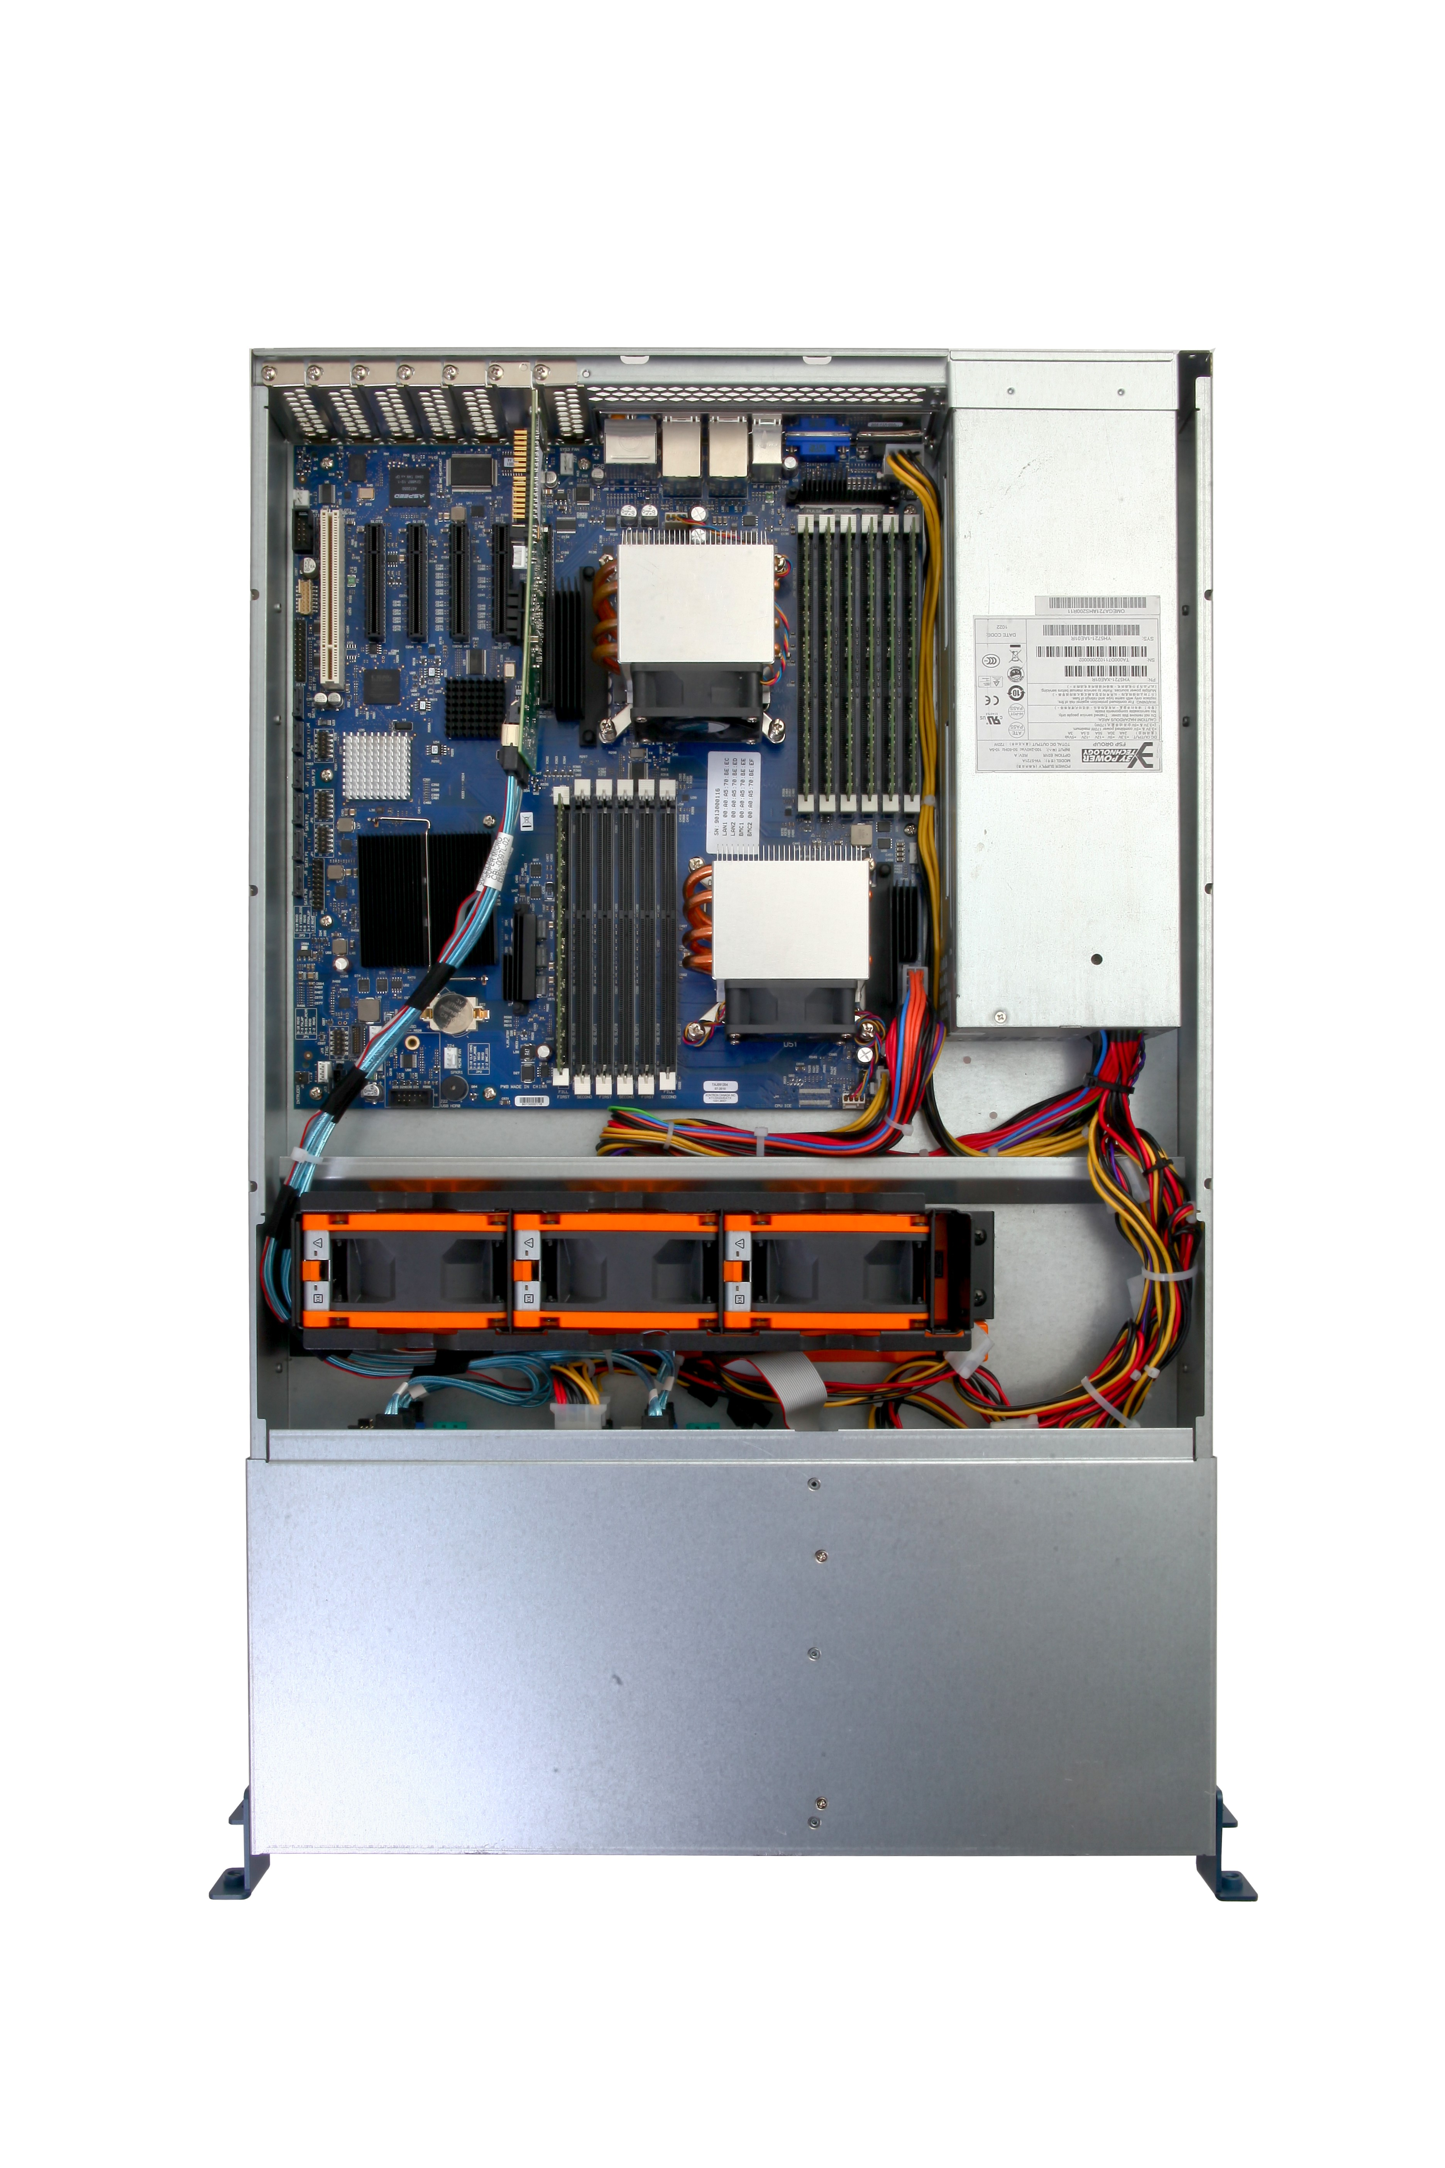
 | 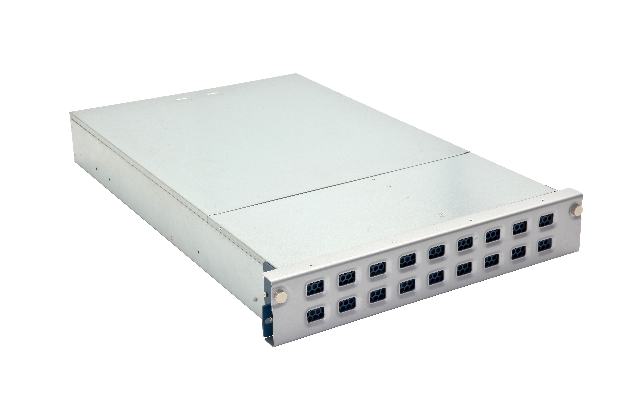

Features & Benefits
- High-efficiency 720w (1+1) redundant power supply
- Support up to 6.0 Gbps SAS/SATA
- Support up to SSI EEB 12" x 13" compliant motherboard
- Fully utilized space to support 12x 2.5" hot-swap HDD
- 4x 80 mm Hot-swappable system cooling fan module
- EMCU provides audible alarm and LED function
- Excellent anti-vibration mechanical design and thermal solution
- Outstanding wire-less design

SPECIFICATIONS
Form Factor (H) x (W) x (D) | 2RU 12-Bay, 19" Rackmount Chassis  3.47" x 17.2" x 25.5"  88.1 mm x 437 mm x 647.7 mm
Drive Bay | 12x 2.5" Hot Swappable HDD Caddy  1x 2.5" Internal HDD Bracket (support 2x 2.5" HDD)  1x 5.25" ODD (Option)  1x Ultra Slim Type DVD (Option)  1x Slim Type FDD (Option)
Mother Board | Up to SSI EEB 12" x 13" (305 mm x 330 mm)
Processor | Dual or Single Intel® or AMD® Processors
Control Panel | 1x System Power Button  1x System Reset Button  1x Alarm Release Button  1x USB 2.0 Port
Indicator | 1x Power Status LED  2x Network Activity LED  1x Overheat LED  1x Fan Failed LED  1x HDD Status LED per HDD  1x HDD Failed LED per HDD  1x Fan Operated LED per Fan Module  1x Fan Failed LED per Fan Module
Expansion Slot | 7x Low Profile Expansion Slot or 3x Standard Expansion Slot
Expander Backplane | 1x 2.5" 6Gbps SAS/SATA HDD Backplane  mini SAS Connector (SFF-8087 including SGPIO)
Fan Module | 4x 80 mm Hot Swappable Fan Module
Electrical Requirement | High-efficiency 720w (1+1) Redundant Power Supply  W/ PFC, AC 90~264V Full Range, 47Hz~63Hz
Monitor and Alarm | Overheat Monitoring and Warning  System Fan Module Status Monitoring and Warning  Power Supply Unit Status Monitoring and Warning  HDD Status Monitoring and Warning
Environmental | Operating: 10˚C~35˚C (50˚F~94.9˚F)  Non-operating: -40˚C~70˚C (-40˚F~158˚F), 5% ~85% Non-condensing
Weight | Enclosure: 16kg (35Ibs)  Packaged: 24kg (53Ibs)  (Hard Drive and Slide Rail Not Included)
Package Dimension (H) x (W) x (D) | 291 mm × 591 mm × 881 mm
INISTOR Headquarter
Address: 5F., No.252, Sec.2, New Taipei Blvd., San Chong Dist., New Taipei City 241, Taiwan, R.O.C.
Tel: +886-2-2995-1439 Fax: +886-2-2995-7705
E-mail: sales@inistor.com

